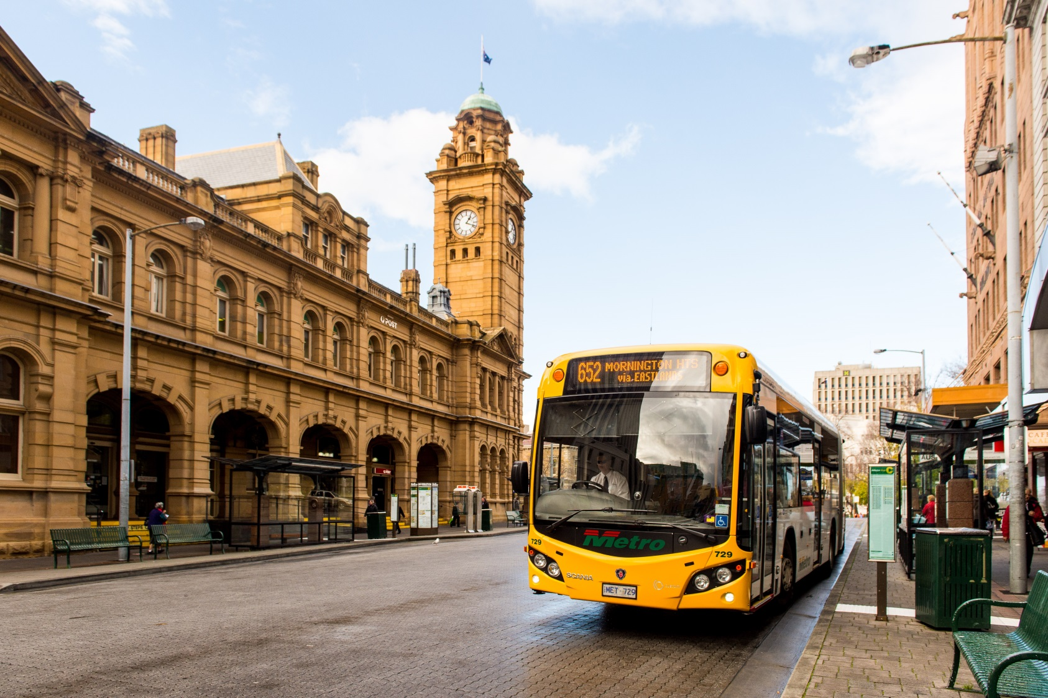

Bus Operator Application Form

Introduction
Thank you for applying for a position with Metro Tasmania.

This application pack forms part of Metro Tasmania’s overall recruitment process. Please read the following information carefully and then provide the details requested so we can evaluate and process your application quickly and effectively.

Who we are
Metro Tasmania Pty Ltd is a State-owned company established in February 1998. The company trades as Metro and operates bus services in Hobart, Launceston and Burnie. Metro is the largest passenger transport company in Tasmania.

Our Vision
To be the most attractive travel option for the Tasmanian public in Metro’s contract areas.

Our Business Purpose
To be a sustainable bus company connecting people and communities.

Our Values

Safety
We take pride in everyone getting home safely, by
- having a safe workplace; and
- putting safety first.

Respect
We show respect for everyone at all times
- by acting with integrity in all our actions, words, and intentions.

Resilience
We have the courage to deal with our day-to-day challenges, showing
- determination
- commitment; and
- strength

Unity
We work together with honesty and transparency.
- We listen.
- We collaborate.
- We cooperate.
- We celebrate success.

Service Driven
We take pride in what we do and it is our pleasure to deliver an outstanding experience for everyone,
- recognising we have internal and external customers;
- continually challenging ourselves to do things better; and
- striving for excellence.

Requirements
In order to be considered for a role with Metro, you must have the following:

Licence
- Be able to meet the requirements set out by the Department of State Growth to obtain an Ancillary Certificate to drive a Public Passenger Vehicle.
Requirements can be found at the Department of State Growth Transport website:
www.transport.tas.gov.au/licensing/getting-a-licence/public_passenger_vehicles_-_ancillary_certificate

Experience
- Previous customer service experience is essential.
- Prior experience in driving a heavy vehicle is highly regarded.

Work Health, Safety, and Environment
Bus Operators have a responsibility to:
- comply with the WH&S regulations, codes of practice and safe work instructions
- before starting any work, ensure their own health and safety and that of others is not endangered by the actions or work they are about to undertake
- report hazards and incidents to their supervisor
- not tamper or interfere with or misuse any device or equipment used for health and safety purposes
- actively participate in health and safety meetings, training and discussions
- follow and comply with safe work instructions, policies and procedures.

Aptitude
Excellent interpersonal and people skills, with the ability to:
- relate to passengers, answer their questions and offer assistance
- understand and comply with the road rules, regulations and industry codes of practice
- understand the specific requirements to assist passengers with special needs to access and use the bus service
- work in a diverse and challenging environment
- carry out written or oral instructions
- write simple correspondence and complete forms

Other Requirements
- Applicants must not have applied for a driving position with Metro Tasmania in the last six months.
- Metro’s fleet of buses are fitted with seats that have a manufacturer’s stated safe working load, for this reason applicants must not weigh more than 130kg.
- If you are successful in gaining employment with Metro you will be required to provide a current National Police Certificate (date of issue within six months) and have or progressing with Working with Children Registration.
For more information on Working with Children Registration please visit:
www.justice.tas.gov.au/working_with_children

How to apply
Please complete the following job application form then attach it to the completed self assessment along with a copy of your resume, qualifications and licences before posting or emailing to Metro Tasmania.

Email to: Post to:
recruitment@metrotas.com.au Human Resources Department
Metro Tasmania
PO Box 61
Moonah Tasmania 7009

Important information for applicants
All correspondence will be sent to you via email.

Metro Tasmania cannot be held responsible if you do not receive important information due to an email address not being provided correctly.

If you do not respond to correspondence sent to you in a timely manner, we will presume you have withdrawn from the recruitment process.

Applicants who submit incomplete applications or do not provide all requested documentation will not be considered for employment.

Self-assessment
Name
This self-assessment is aimed at helping you determine whether you have the necessary qualifications, capabilities and qualities required to be a professional Bus Operator.

Mandatory – must have | No | Yes | Details if applicable
Be able to meet the requirements set out by the Department of State Growth to obtain an Ancillary Certificate to drive a Public Passenger Vehicle.
Be able to provide a current National Police Certificate (date of issue within last six months)
Have or progressing towards a Working with Children Registration (provide registration number)
Australian citizenship, permanent residency status or a visa that allows you to work in Australia (provide copy)
Willingness to undergo a medical assessment (at the company’s expense) that includes providing a urine sample for drug testing and undertaking a physical assessment
Willingness to undertake periodical drug and alcohol testing
A passion to drive in a safe and professional manner
Your own reliable transport
Desirable – I also have | No | Yes | Details if applicable
A current Medium Rigid (MR), Heavy Rigid (HR) or Heavy Combination (HC) licence
Experience in customer service
Experience in previous shift work
I am willing and able to | No | Yes | Details if applicable
Adhere to Metro’s Values
Comply with the WH&S regulations, codes of practice and safe work instructions
Deliver high quality service to Metro customers
Contribute to Metro’s commitment to a harmonious and diverse workforce

Confidential
Employment Application Form

Position you are applying for

Full-Time Part-Time Casual

Location of position you are applying for

Hobart Launceston Burnie Latrobe

Personal details
Full name:
Residential address:
Postal address:

Contact details
Email
Mobile
Home

Driver’s licence details
Please attach a copy of your Drivers licence when submitting your application.
Driver’s licence number: |  |  |  | Expiry Date:
Class: |  |  |  | State:
Licence conditions

Other qualifications and competencies
Please list any other qualifications, certificates of competence or additional experience you may have:

Employment history
Please provide details of employment for the last 10 years, starting with your most recent employer.

Employer:
Position:
Commenced employment |  |  |  | Finished employment
Reason for leaving:

Employer:
Position:
Commenced employment |  |  |  | Finished employment
Reason for leaving:

Employer:
Position:
Commenced employment |  |  |  | Finished employment
Reason for leaving:

Employer:
Position:
Commenced employment |  |  |  | Finished employment
Reason for leaving:

Employer:
Position:
Commenced employment |  |  |  | Finished employment
Reason for leaving:

References
Referees should be supervisors or managers and cannot be work colleagues. If you are unable to provide management references please outline why and provide optional references. Please confirm the following:

In providing references, I consent to verbal or written information being obtained from my referees for the purposes of assessing my suitability for this position.

I have notified my referees that they may be contacted and understand that the information will be supplied by my references in confidence.

Name and title: |  |  | Company:
Relationship to applicant:
Contact details:

Name and title: |  |  | Company:
Relationship to applicant:
Contact details:

Name and title: |  |  | Company:
Relationship to applicant:
Contact details:

Health and wellness
It is your responsibility to ensure that you do not have any medical condition that may affect your ability to carry out the functions and responsibilities of the position.
Describe your current state of health

Excellent Very Good Average

What is you weight | kg

Are you aware of any reason, medical or otherwise, why you may not be able to obtain an Ancillary Certificate to drive a Public Passenger Vehicle?

No Yes

or

Are you aware of any reason, medical or otherwise, why you may not be able to completely perform the duties of a Bus Operator?

No Yes
If you answered yes to either of the above questions, please provide further details:

Compensation
Have you ever received or are you currently receiving any Workers Compensation for any injury or disease?
No Yes
If you answered yes, please provide further details:
Employer at the time:
Period of injury or illness:
Details:

Employer at the time:
Period of injury or illness:
Details:

Declaration
I hereby declare;
- that the answers to the above questions are, to the best of my knowledge, true and correct;*
- I fully understand that I must agree to register a zero (0.00%) drug and alcohol level at all times during working hours or at any other time while in charge of a company vehicle plant or equipment and that I may be requested to undertake a drug and alcohol test to determine this;
- that I agree to undergo any medical examination (at the expense of the company) as may be requested by Metro Tasmania, whether before or after employment has commenced;
- that if my application for employment is accepted, I will be bound by and will at all times observe and respect such terms and conditions of employment and such policies and procedures as may from time to time be specified or otherwise stipulated by Metro Tasmania;
- I fully understand that if my answers to any of the questions above are misleading, or do not disclose a condition or restriction that inhibits me from meeting the full requirements of the position of Bus Operator carrying public passengers, that Metro Tasmania will consider it to be repudiation of the contract of employment resulting from this application, for which termination of employment will be justified; and
- I acknowledge that Metro Tasmania operates under an Award/Enterprise Agreement. I shall adhere to the provisions and conditions as specified within the Award/Agreement.
- I acknowledge that Metro Tasmania operates under a Code of Conduct and if my application for employment is accepted I will be required to comply with the standards outlined in the Code of Conduct.
Signed |  | Date:

